24.14: a) 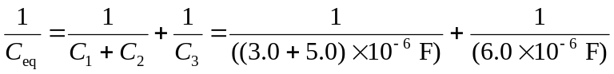
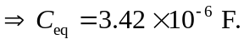
The magnitude of the charge for capacitors in series is equal, while the charge is distributed for capacitors in parallel. Therefore,
Since  and  are at the same potential, 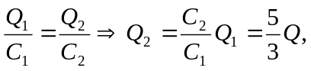
b)
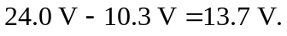
c) The potential difference between a and d: 